Class Diagram



Updated ERD



Physical Design



DatabaseTable Implementation code

CREATE Database ICSFinances;

CREATE TABLE EDAVILA.ICSFinances.dbo.Users (

UserId int IDENTITY(1,1) PRIMARY KEY NOT NULL,

HashedPassword varchar(100) NOT NULL,

UserName varchar(20)NOT NULL,

FirstName varchar(20)NOT NULL,

LastName varchar(20)NOT NULL,

EmailAddress varchar(100)NOT NULL,

UserLevel int NOT NULL,

AccountStatus int NOT NULL,

EntryDate datetime NOT NULL,

UpdateDate datetime NOT NULL

);

CREATE TABLE EDAVILA.ICSFinances.dbo.Levels (

Id int IDENTITY(1,1) PRIMARY KEY NOT NULL,

LevelDesc varchar(1000),

EntryDate datetime NOT NULL,

UpdateDate datetime NOT NULL

);

CREATE TABLE EDAVILA.ICSFinances.dbo.Topic (

Id int IDENTITY(1,1) PRIMARY KEY NOT NULL,

TopicName varchar(40) NOT NULL,

);

CREATE TABLE EDAVILA.ICSFinances.dbo.Lessons (

Id int IDENTITY(1,1) PRIMARY KEY NOT NULL,

LessonName varchar(40) NOT NULL,

SiteLocation varchar(100) NOT NULL,

LsssonLevel int NOT NULL,

EntryDate datetime NOT NULL,

UpdateDate datetime NOT NULL

);

CREATE TABLE EDAVILA.ICSFinances.dbo.BlogPosting (

Id int IDENTITY(1,1) PRIMARY KEY NOT NULL,

UserID varchar(20)NOT NULL,

Topic int NOT NULL,

PostTitle varchar(300)NOT NULL,

Message varchar(3000)NOT NULL,

RelatedPost int NOT NULL,

EntryDate datetime NOT NULL,

UpdateDate datetime NOT NULL

);

Creating a new User:

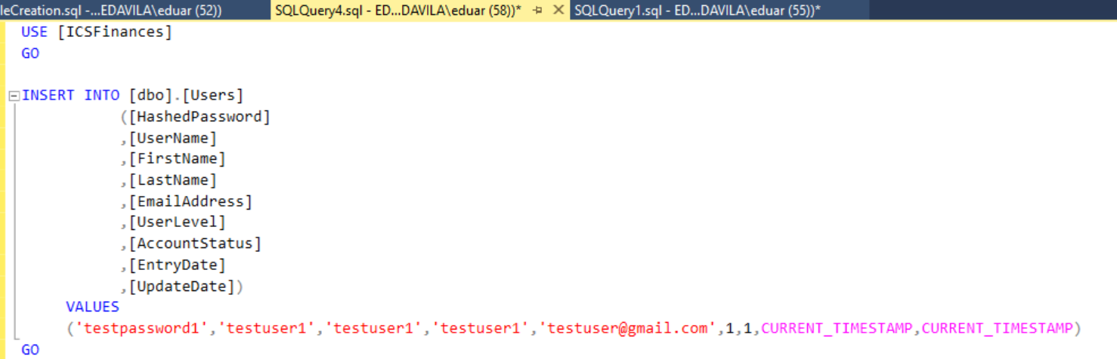





Updating Password for said user.

